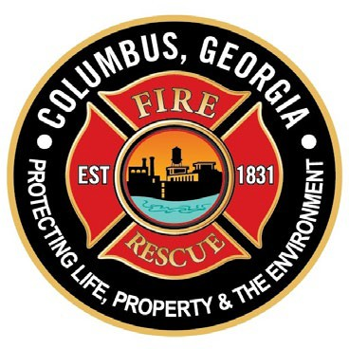
B. H. “Skip” Henderson, III
Mayor/Director of Public Safety
COLUMBUS DEPARTMENT OF FIRE AND EMERGENCY MEDICAL SERVICES
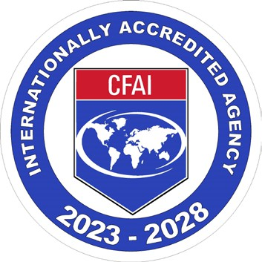
“We do amazing”

Salvatore J. Scarpa
FIRE-EMS Chief
510 l0TH Street
Columbus, Georgia 31901
Sal Scarpa
FIRE-EMS Chief
(706) 225-3500 Fax (706) 225-3504

FOR IMMEDIATE RELEASE
May 27, 2026
Media Contact:
Deputy Chief Daniel Macon Columbus Fire & EMS
706-225-3758 | dmacon@columbusga.org

FOR IMMEDIATE RELEASE
Mayor’s Commission on Health, Columbus Fire and EMS, and Columbus Correct Care Host Community Health Resource Fair.

Columbus, GA — June 6, 2026 — The Mayor’s Commission on Health, in partnership with Columbus Fire and EMS, and Columbus Correct Care, will host a Community Health Resource Fair on Saturday, June 6, 2026, from 10:00 a.m. to 1:00 p.m. South Columbus Public Library, 2034 South Lumpkin Rd, Columbus, GA. 31903.
This free public event combines health, safety, and community engagement in one accessible location. Multiple vendors will be on site offering free or low-cost services, including Valley Healthcare, Food Mill, Piedmont, Oak Street Health, Safe House, METRA, and many additional community partners.
In addition to health services such as vital sign checks, health resource materials, and fire safety education, the event will feature, music, games, and family-friendly activities.
METRA offers transportation for the event. Get vouchers at the METRA Transfer Center or from a bus operator for tickets to the event; return vouchers are available at the METRA table.

